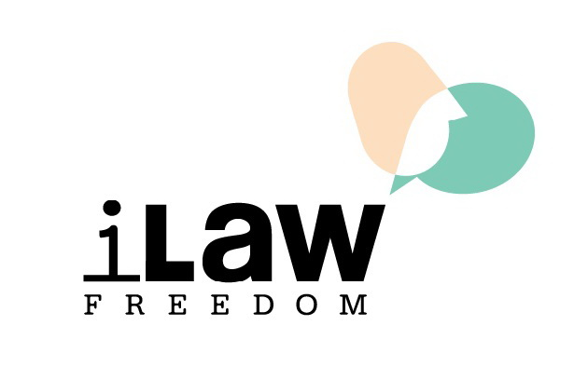

FIDH - International Federation for Human Rights
and its member organizations in Thailand
Union for Civil Liberty (UCL)
and
Internet Law Reform Dialogue (iLaw)

Joint press release

Thailand: Government fails to address UN concerns in follow-up human rights review

Bangkok, Geneva, Paris, 27 April 2020: Thailand has failed to address concerns raised by the United Nations (UN) Human Rights Committee (CCPR) with regard to key civil and political rights, FIDH and its member organizations Union for Civil Liberty (UCL) and Internet Law Reform Dialogue (iLaw) said today.

FIDH, UCL, and iLaw today submitted a second follow-up shadow report to the CCPR, in which they detailed the Thai government’s ongoing failure to implement the recommendations made by the CCPR in March 2017 on the following priority issues: 1) The constitution and the country’s legal framework; 2) Extrajudicial killings, enforced disappearances, and torture; and 3) Conditions of detention. FIDH, UCL, and iLaw had issued their first follow-up shadow report in August 2018.

“Thailand’s government has once again shown that it is unwilling or unable to address the UN’s human rights concerns. The UN should acknowledge the Thai government’s ongoing failure to uphold civil and political rights and continue to make recommendations for improvement,” said FIDH Vice-President Guissou Jahangiri.

The CCPR will conduct the follow-up review of Thailand during its 129th session, which is set to be held from 29 June to 24 July 2020 in Geneva, Switzerland.

With regard to the country’s legal framework, the constitution promulgated in April 2017 contains provisions that allowed repressive decrees issued by the military junta to remain in place until its dissolution in July 2019. Several of these repressive decrees remain in effect to date. Other problematic provisions of the 2017 constitution clash with democratic principles and ensure that the military will retain its grip on power for the next several years.

“The repressive legacy of the military junta lives on despite its formal dissolution. The UN should signal to the Thai government that urgent and substantive action is needed to restore the rule of law, respect of civil and political rights, and uphold democratic principles,” said iLaw Executive Director Jon Ungpakorn.

The Thai government has also failed to implement the CCPR’s recommendations on torture, extrajudicial killings, and enforced disappearances. Reports of these types of human rights violations persist, as do reports of impunity for perpetrators of such violations due to inadequate investigations of these cases, contrary to Thailand’s obligations under the International Covenant on Civil and Political Rights (ICCPR).

With regard to detention conditions, Thailand has failed to take tangible steps to reduce prison overcrowding, guarantee that detainees are treated with humanity and dignity, or ensure that conditions of detention in all Thai jails are in line with international standards, as recommended by the CCPR.

“Thailand’s prison population has increased by more than 30% since the UN review in March 2017. Severe overcrowding and sub-standard conditions mean that Thai prisons are a ticking time bomb ready to explode. The Thai government must urgently undertake policy reforms that address the root causes of this crisis,” said UCL Vice-President Gawin Chutima.

The CCPR monitors states parties’ compliance with their legal obligations under the ICCPR. Thailand is a state party to the ICCPR. Thailand’s second periodic review under the ICCPR was examined by the CCPR on 13-14 March 2017.

Press contact
Ms. Eva Canan (French, English) - Tel: +33648059157 (Paris)

